A Forest Fire Identification Method for Unmanned Aerial Vehicle Monitoring Video Images

In this paper author is identifying fire from UAV videos by applying techniques below techniques

1. Image Processing which will read video frame by frame and then convert BGR image format to RGB format
2. Motion Detection: using python OPENCV we will detect movement from video and if moving object 0-90 degree then we will extract moving area
3. Colour Features Extraction: using this we will extract colour related to fire which will help in detecting fire or smoke
4. Wavelet and Texture Extraction: Wavelet and texture features will be extracted to identify weather colour features is fire or not and if fire then it will output as fire detected

SCREEN SHOTS

Double click on run.bat file to get below screen

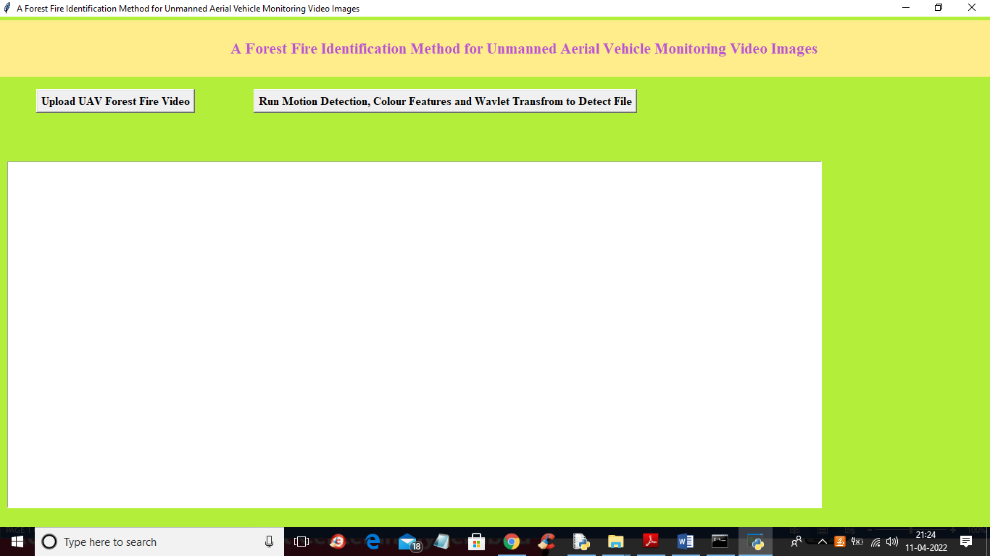

In above screen click on ‘Upload UAV Forest Fire Video’ button to upload video and get below output

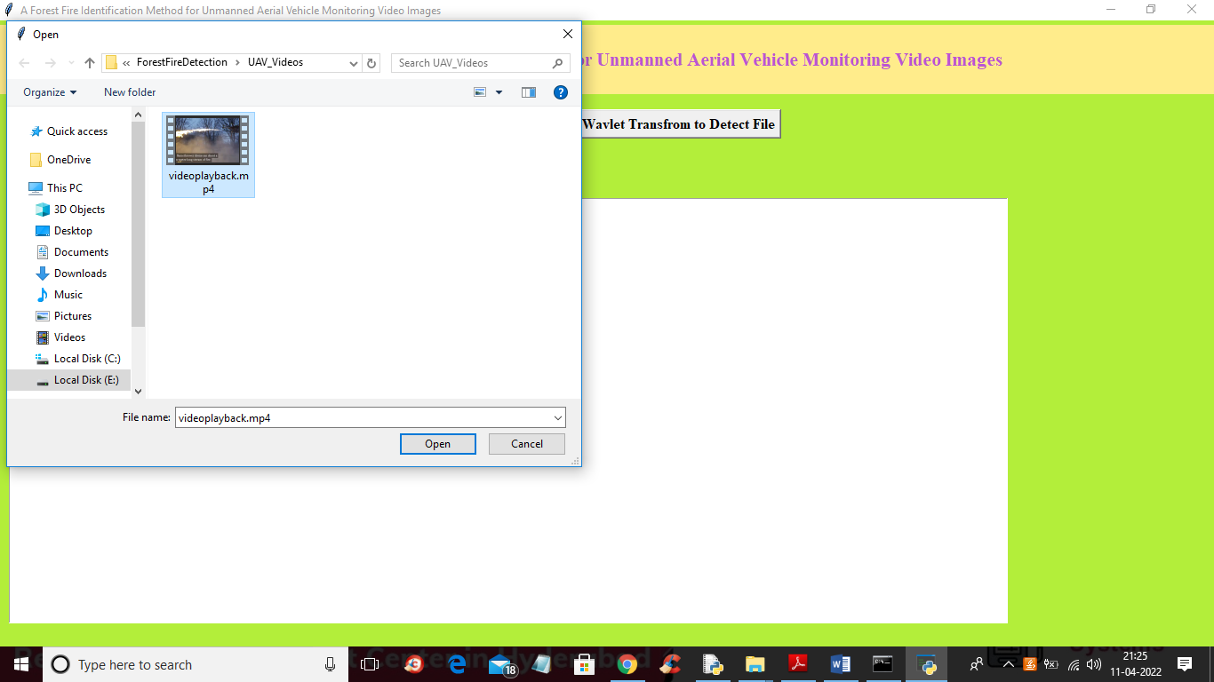

In above screen selecting and uploading video and then click on ‘Open’ button to upload video and then click on ‘Run Motion Detection, Colour Features and Wavlet Transfrom to Detect File’ button to get below output

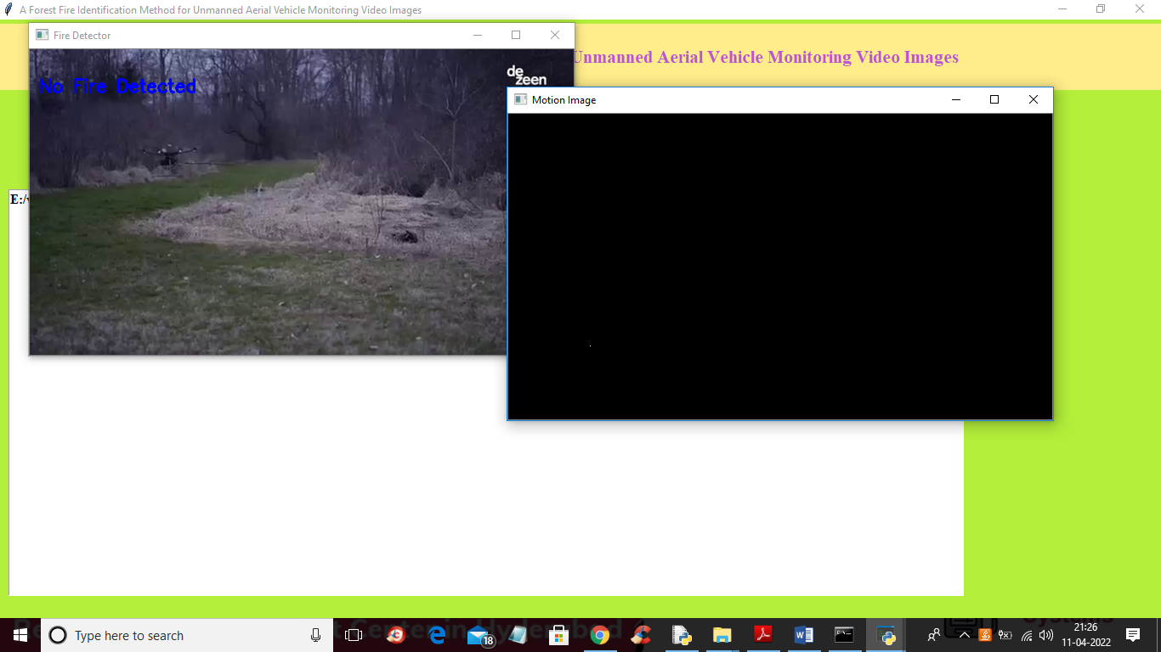

In above screen you can see no fire detected and in black screen also no fire movement detected and in below screen we can see fire detected with movement in black window

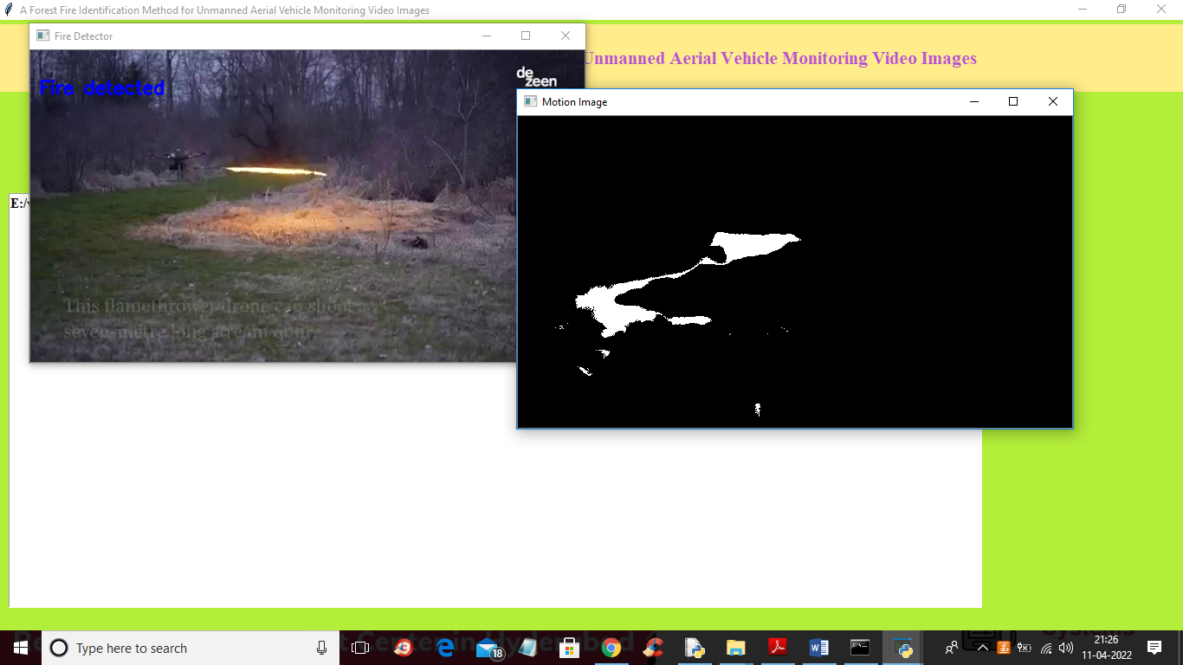

In above screen fire detected and movement we can see in black screen

